*Table of Contents page numbers*

*Portfolio 1.1 -----------------------------------------------------------------------------------*

*Portfolio 1.2 -----------------------------------------------------------------------------------*

*Portfolio 1.3 -----------------------------------------------------------------------------------*

*Portfolio 1.4 -----------------------------------------------------------------------------------*

*Portfolio 1.5-----------------------------------------------------------------------------------*

*Portfolio 1.6 -----------------------------------------------------------------------------------*

# **Portfolio 1.1**

**Project Proposal**

**Website Title**: House of Cards

**Developer and Role**:

The developer designs the site with the given specifications for the client of House of Cards*.* And follow the given specifications and requirements. All the images and required assets are provided by the client and developer has no role in modifying them or creating a new asset except the site pages.

**Project Focus:**

This projects focus on designing the house of cards website with brief information about the business and increase the business by attracting the customers who are not aware of the business.

**Site Plan:**

**Site Elements:**

* Brand name and brand logo should be displayed on every page
* Navigate to home page by clicking the logo or home button
* Site should be loaded on all browsers
* Copyright notice must be displayed in the footer sections of the page

**Web Content:**

As web pages need to be descriptive with each type of cards, it might be over 20 pages including business hours and contact

**Target of audience:**

The audience of this site would be online users who are trying to know more about the House of cards business and their services

**Design Considerations:**

* Pages must be opening in all browsers
* Logo must be placed in all pages and when clicked should be navigated in to the index page
* Alt tags must be added to images in case of display issues on the web page

**Limiting factors:**

* Third party plugins and softwares must be avoided except editors to design the pages
* Python, PHP and other scripting languages must be avoided
* No dynamic functionality is allowed.
* No libraries should be used as dependencies
* All css must be written in stylesheet and must be linked no url for it should be used

**Portfolio 1.2:**

**Home page:**

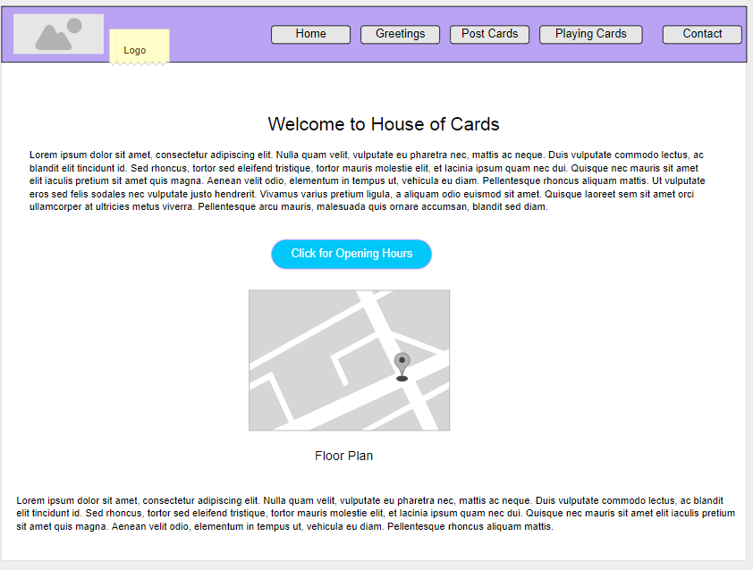

**Figure: index page mock up**

**Cards Page:**

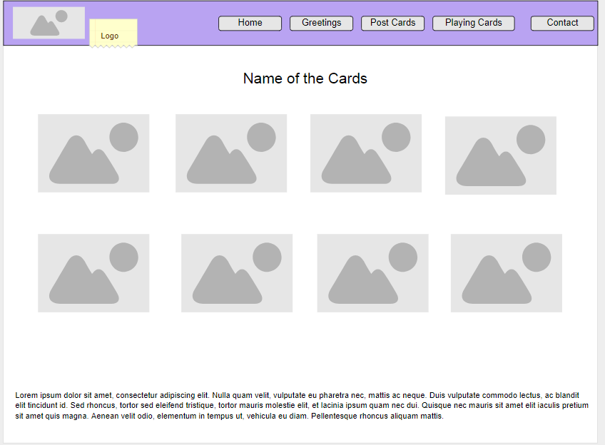

**Figure: Greetings page thumbnail view**

**Business Hours page:**

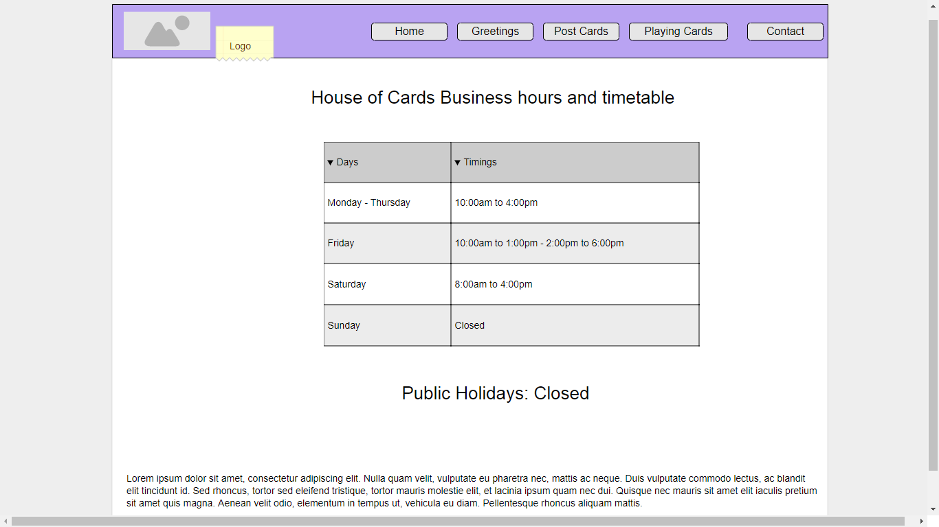

**Figure: Timings, - House of cards**

**Portfolio 1.3**

**Website Specification:**

**Client***:* House of Cards

**Specifications***:*

* Enough information should be provided to the customers visiting the website
* Visitors should obtain the overview of business and layout of the shop
* Should be able to know the timings and work hours and address of the shop
* Brief description of products and information of the business to be provided to run the business in offline
* Design the application with good user interface for accessing the content on the website

**Success Measurement:**

* Success can be measured using various factors like:

1. Increasing the visitors to the offline and online
2. Good insight of the business and shop layout
3. Increase the traffic for online website and offline customers to the shop
4. Connect the users who are not aware of the business

**Mission***:*

The mission of this project is to develop the House of cards website with the given specifications and requirement and provide enough information to the visitors who are interested in House of cards business.

**Target Audience*:***

No specific kind of audiences are targeted, anyone who is interested in House of cards business and would like to know more are provided enough information to shop offline.

**Technical Limitations for Developing:**

1. Only Combination of HTML5 and CSS3 must be used
2. Rapid Application development tools cannot be used in designing or developing the site
3. No scripting languages like JavaScript, python, ruby can be used
4. No third party services or add-ons can be used
5. No external libraries can liked or attached
6. Site should be developed without any automation tools or visual design tools.
7. Web page can be opened just by clicking the index page of the site and no tools should be required other than the target browser or any browser for sake of it.
8. No servers should be used and other interaction should be between the pages and visitors, is static ,i.e., just to browse the information
9. No scripting can be used
10. Only static content is shown i.e. the site is entirely designed in HTML and CSS

**Flow Chart**

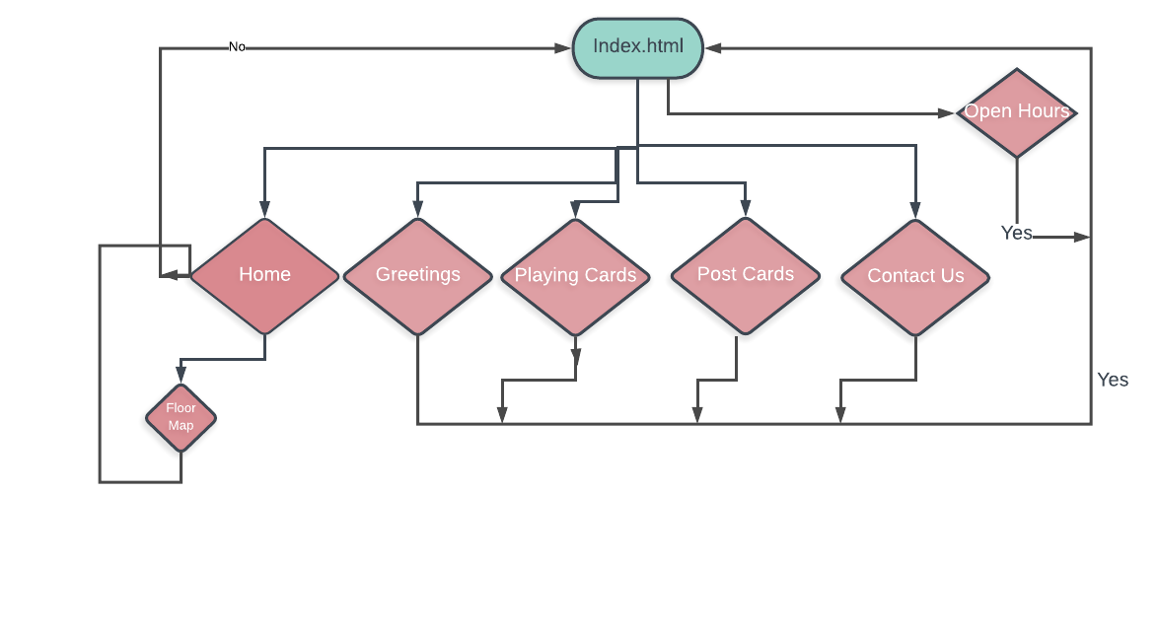

**Figure: Flow chart**

**Flow chart Description:**

1. Index page connects all pages through menu bar
2. Visitor can navigate to any page from any page
3. Visitor can land in home page just by clicking the logo.

The design and structure is simple and easy for any kind of user who has little knowledge of interacting with browsers and websites as user can easily obtain information and find pages.

This design is most simple in nature and can be browsed by any kind of person

**Portfolio 1.4**

**Site Design:**

* House of cards site is designed with pure html and css
* Classes are used as identifiers in writing the css styles
* Each page contains navigation and title of the page
* Inline styles are rarely used and implemented
* HTML5 tags are used to for easy readability of the mark up like section, footer , nav etc.,

**HTML Document sections*:***

**Each** page and document have similar structure and contains various sections and sub-sections. But every html document has 3 main sections:

1. Header section
2. Body Section
3. Footer Section

Header sections:

* Contains title
* Meta tags
* Link to external stylesheets

Sample head tag

{

<head>

<title of the page>

<link to stylesheet>

<meta tag / view port scaling>

</head>

}

2.Sample Body tag/ section

Body{

<body>

<navigation-menu>

<brand-logo>

<list of menus>

</navigation-menu>

<main-section>

<thumnails of cards>

</main-section>

</body>

}

3.Footer Section:

Footer{

<footer class>

<footer>

<p>Copyright infomration</p>

</footer>

</footer class>

}

**Portfolio 1.5:**

**Headings, Classes, Identifiers and Typography**

1. H1, h2, h3 headings are used in the entire design the site
2. Font size and weight are increased according if needed
3. Line heights and letters pacing are used to magnify and print the text on the webpage
4. Bold and italic tags are used as appropriate

**Connections, colours and Hyperlinks**

1. Text decoration is removed through all the html pages
2. Additional styles are added to hyperlinks
3. Hover effects and transition properties are used for buttons, links and images.
4. Extra paddings and margins are added to menus, links, buttons and images
5. colours and gradient colour scheme is used for navigation menu

**Class Names:**

Different class names are used to identify different sections of the page

For e.g.: navigation class for menu and navigation

* Main-content for body and display of content
* Header class for heading and brand logo
* Footer class for footer text and copyright
* Logo class for placing and managing logo of the site
* Table class and open hours class for creating a table and managing the content of the opening hours

**Portfolio 1.6.**

* Box model allows the developer to adjust the elements and content on the webpage in a structured manner
* Space on the webpage can be managed easily with this model
* Allows to manage the content on different screen sizes and resolutions without any interference between the elements.
* Typography and typefaces can be easily adjusted and manipulated to display effectively.
* Body or main container will have a width of 96% and margin adjusted accordingly on the other ends
* Padding of the elements and images will be adjusted according to the screen resolutions

**Box model before design**

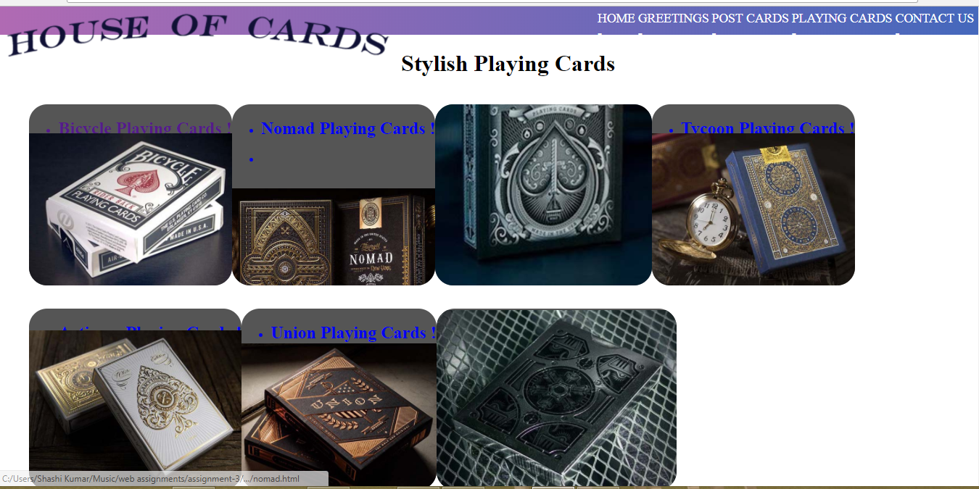

**Figure: without paddings, margins, line heights etc.**

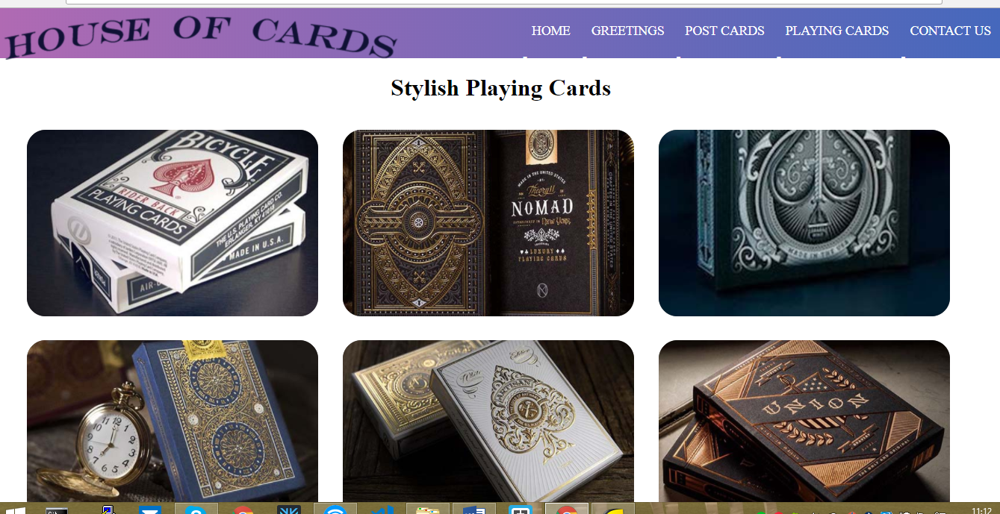

***Figure: Box model used***

* *This application completely takes advantages of box model and structured in a required way using paddings, margins etc.*